Lunchtime Plan Name:
Monday | Tuesday | Wednesday | Thursday | Friday
Outside | Art Club | Lego club | Art Club | Outside
Warning – an adult will remind me of the right thing to do

If I have a yellow card incident;  - Time out on the playground – stand next to the person on duty (minimal communication). | 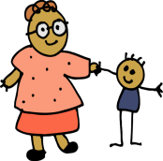
If I have a red card incident – I will have time out of play and my teacher/parents will be told
2. Miss part of break or lunchtime
3. Spend the next day break or lunch in isolation with SLT
On outside days – a key worker (AM) will monitor his/her ability to interact appropriately with peers. Please follow consequence ladder below.
Playtime Story
Sometimes I get frustrated and upset when things don’t go my way. I might kick or punch or hurt someone. That makes other children really sad.
Instead of hurting someone, I should try some of these things;
Walk away or speak to an adult
Sit on the bench
Count backwards from 50 in 5’s
Think of my calm place
If I can do one of these things, the adults will be happy and I will get a tick on my chart

