I am an ELSA  What is an ELSA????  - An ELSA is a member of staff who is trained as an Emotional Literacy Support Assistant to support children with their developing emotional literacy  Let me explain  Hmm, what is emotional literacy?  Emotional Literacy is:  - how children understand and cope with the feelings of ourselves and others  - develop high self-esteem and positive interactions with others  - being emotionally literate helps children focus better on their learning  - The child`s needs could be recognising emotions, self-esteem, social and friendship skills, anger management, loss and bereavement  This is a good question  How do you help a child with Emotional Literacy Support?  - It is very important to build a relationship with the child. Every child is unique and I believe in them and I`m interested in them.  - I find out their interests, worries, strengths, weaknesses and who is significant in their lives,  - Through this information and the knowledge from the class teacher, I work out a programme for the child.  - The programme could be on anger management, friendship and social skills, self-image to loss and bereavement  - All these emotions stop a child from learning to their potential, therefore, it is wise to intervene with some emotional support so that they do not bottle up their feelings to a stage where they cannot learn  - I visually demonstrate anger through the use of a firework model and the fuse before explosion.  - I use puppets to listen to the child and ‘answer’ appropriately  - I encourage the child to draw, colour, build things, make crafts so their kinasethic skills are being used.  AN ELSA IS IN SCHOOL TO HELP AND SUPPORT ALL CHILDREN IN ANY WAY THEY CAN  Sonia Green November 2012  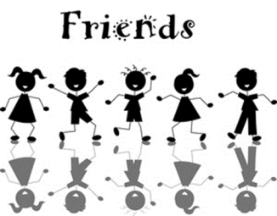  FRIENDSHIPS  CONFIDENCE  ELSA is an:  EMOTIONAL LITERACY SUPPORT ASSISTANT  WHO TALKS AND LISTENS TO CHILDREN; SUPPORTS THEM AND FINDS WAYS TO HELP WITH THEIR  LEARNING, FRIENDSHIPS, CONFIDENCE AND EMOTIONS  EMOTIONS  LEARNING | Sounds great having someone to talk to and work with. How does this work in school?  Children enjoy having some, one to one time with an adult and being able to talk about their feelings, school and other issues.  - With the parents’ consent the child`s teacher completes a referral form for the ELSA to follow  - An ELSA often works with children on a One to One basis but sometimes the children may work in a group, all activities are tailored to their needs  - Each week a child has a 30 minute to an hour slot with an ELSA  - All sessions are fun and could include role play, puppets, games, art, crafts and stories  - There is always time to talk  - Every child`s progress is monitored and reviewed on a half-termly basis  - The child`s teacher and Head teacher are informed of progress and any concerns

