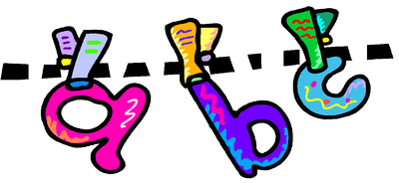
Phonics Terminology
What is phonics?
Phonics is the way children are taught to read, write and spell in schools today and is sometimes called ‘letters and sounds.’ This guide tells you about some of the terms you may hear teachers use when talking about phonics. Phonics is the prime approach to teaching children to both read and spell early on in their learning. Through phonics teaching, children learn the necessary skills as well as the different letter-sound relationships that help them to work out how to read a new word, as well as how to have an attempt at spelling words.

Adjacent consonants | Two (or three) letters making two (or three) sounds next to each other in a word. e.g. the first three letters of strap are adjacent consonants.
Blending | Saying the individual sounds that make up a word and then merging or blending the sounds together to say the word – used when reading.  e.g. s-n-a-p, blended together, reads snap.
Cluster | Two (or three) letters making two (or three) sounds, e.g. the first three letters of 'straight' are a consonant cluster
Consonant digraph | Two consonants which make one sound. e.g. sh, ch, th, ph
CVC, CCVCC etc. | The abbreviations used for consonant-vowel-consonant and consonant-consonant-vowel-consonant-consonant words, used to describe the order of sounds. e.g. cat, ship and sheep are all CVC words. Black and prize could be described as CCVC words.
Digraph | Two letters which together make one sound. There are different types of digraph – vowel, consonant and split.
Grapheme | A letter or group of letters representing one sound (phoneme)  e.g. ck, igh, t, sh
Phoneme | The smallest unit of sound in a word. There are generally 44 phonemes in English, depending upon accent and articulation.
Pure sound | Pronouncing each letter sound clearly and distinctly without adding additional sounds to the end e.g. ‘f’ not ‘fuh.
Segmenting | The process of using phonics for writing. Children listen to the whole word and break it down into the individual phonemes. Children can count the number of phonemes in each word. e.g. ship can be segmented as sh-i-p.
Split digraph | Two letters, which work together to make one sound, but are separated within the word. e.g. a-e as in make or late; i-e as in size or write. Previously known as “Magic e”
Trigraph | Three letters which together make one sound. e.g. dge, igh, tch
Vowel digraph | A digraph in which at least one of the letters is a vowel e.g. ea, ay, ai, ar.

