Home Learning Activities for Year 6 Date: 29.06.20
English | Maths
This week we are going to be putting our balanced argument together, using all of the evidence you have collected over this term. The question you will be looking to answer is: ‘Is it ever right to break the rules to effect a good outcome?’  Task 1  Look through this balanced argument PowerPoint (https://www.twinkl.co.uk/resource/t2-e-4791-ks2-writing-a-balanced-argument-activity-pack) and what to include. Add to the word bank you started creating last week; specifically looking at cohesive words and phrases to help make your arguments easy for your readers to understand and identify.  Looking at the question you have been given, start to complete a table with points that are for breaking the rules to effect a good outcome and then points that support this never being ok regardless.  Task 2  Look through this PowerPoint (https://www.twinkl.co.uk/resource/au-t2-e-3862-peel-paragraphing-resource-pack) on PEEL (Point, evidence, explain and link). You will need to take your argument points and start to build up PEEL paragraphs to support each one. Have a go at doing this for at least two of your points!  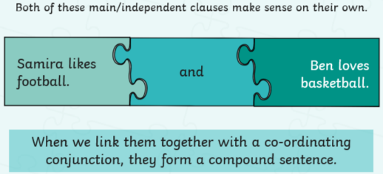  Spelling: Coordinating conjunctions.  Use the example to help you complete both spellings tasks!  Task 1  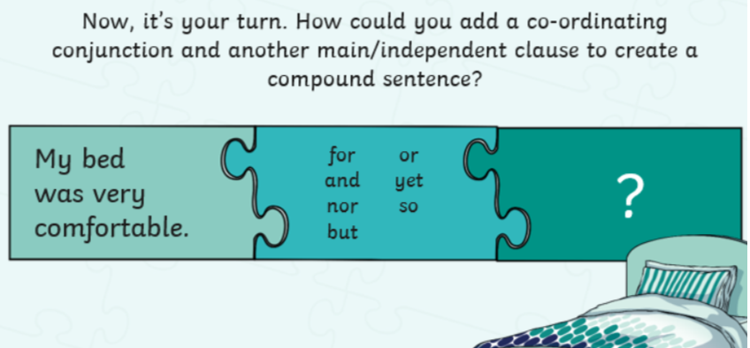  Task 2  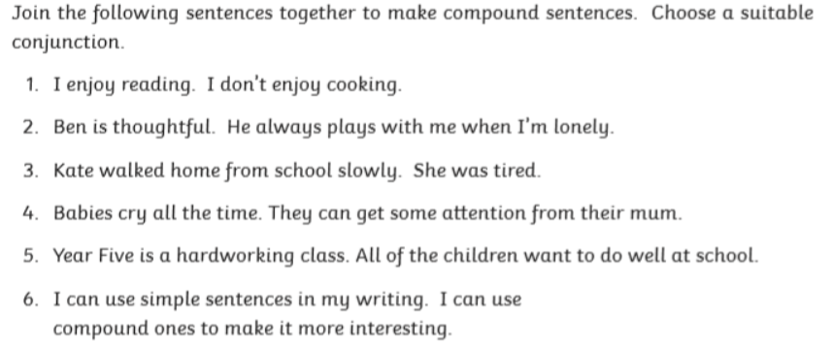  Reading: Have a go at the comprehension about celebrating the NHS! * = mild, ** = medium and *** = spicy. | This week in school, we are going to be consolidating our learning on angles from a few weeks ago. Try these challenges below.  Remember:  - Angles in a triangle add up to 180$°$  - Angles on a straight line add up to 180$°$  - Angles around a point add up to 360$°$  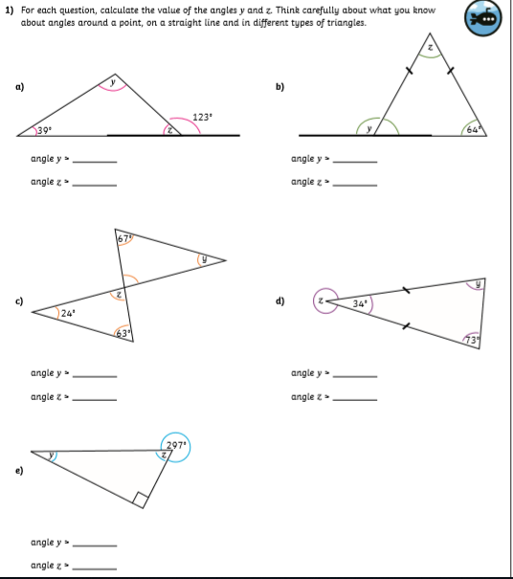
Theme | PE
This week, we would like for you to create your very own human skeleton, complete with muscles. You can draw or make it, and try to make it as realistic as possible.  You do not need to include all of the bones and muscles found in the human bottle (as there obviously quite a lot) but websites like BBC Bitesize will give you a lots of the common ones. Don’t forget to give your new human a name! | We would like for you to think about all of the Sports Days you have had a John Rankin since the very start of your journey through the school, and then come up with your top 3 activities.  Then, we would like for you to plan your very own JRS (socially distancing) Sports Day, with 10 activities and a scoring system for 6 different bubbles.  Good luck!

Links to support this learning | Supporting Information for parents
English  https://www.bbc.co.uk/bitesize/topics/zwwp8mn/articles/z9wvqhv  Maths  Want some extra resources on properties of shape? –  https://whiterosemaths.com/wp-content/uploads/2019/SoLs/Primary/Summer_Term_SOL/Year-6-2018-19-Summer-Block-1-Properties-of-Shape.pdf | English:  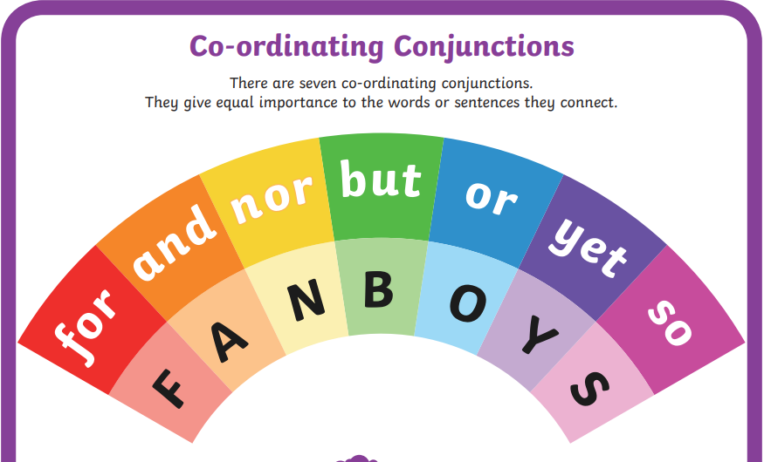  Maths - answers:  