Year 3 Creative Curriculum - Autumn Term 2018
English  During this term we will be covering:  - Fiction: traditional stories and poetry.  - Non Fiction: instructions and newspapers.  - Spelling: prefixes, suffixes, homophones, spelling strategies and patterns.  We will be learning to;  - Use capital letters, full stops, exclamation marks and question marks accurately in sentences.  - Write compound sentences using the conjunctions and, or, but, so, for, nor, yet.  - Use the conjunctions: when, before, after, while, so and because in our sentences.  - Use adjectives to add description to our writing.  - Start our sentences in different ways using fronted adverbials.  - Understand the 5 story parts and use these to structure and plan stories.  - Assess how effective our own and other people’s writing is.  - Suggest improvements to a piece of writing. |  | 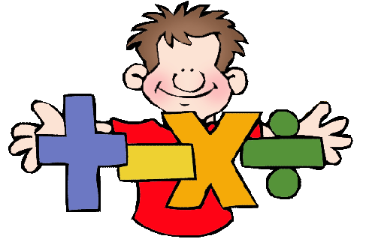  Maths  Children will be learning:  - Numbers and Place Value – counting in multiples of 4, 8, 50 and 100, finding 10 and 100 more and 10 less, read and write numbers with three digits, compare represent and order numbers.  - Statistics - interpret and present data using bar charts, pictograms and tables and solve problems relating to these.  - Addition and Subtraction - add and subtract numbers mentally, use formal written methods of column addition and subtraction to solve problems, check answers.  - Multiplication and Division - recall and use multiplication and division facts for the 3, 4 and 8 tables, write and calculate mathematical statements for multiplication and division progressing to formal written methods, solve problems.  - Properties of Shape - draw 2-D shapes and make 3-D shapes using modelling materials; recognise 3-D shapes in different orientations and describe them.
Autumn Term 1 – Excellent Egyptians  Children will:  - Know about the main events, dates and beliefs in Ancient Egypt.  - Know about the lives of people in Egypt.  - Be able to gather information from simple sources.  - Understand that the past has been recorded in a variety of different ways.  - Locate Egypt on the map and understand the importance of different geographical features.  Art/DT  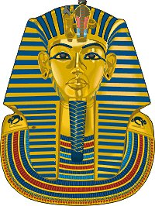  Children will:  - Be able to choose materials and techniques which are appropriate for their task.  - Be able to explain their own work in terms of what they have done and why.  - Be able to talk about works of art, giving reasons for their opinions. | 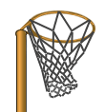  PE  St Barts Sports Leaders from years 10 and 11 will lead supervised sessions on a range of team games including rugby and netball.  Jigsaw - PSHE  Being me in my world.  Italian  Greetings, Classroom Instructions, Weather, Colours, Food and the House |  | Autumn Term 2 – Our Newbury Neighbourhood  Children will:  - Locate and name the continents on a World Map and the main counties and cities in/around Newbury.  - Understand geographical similarities and differences through studying the human and physical geography of our local area and comparing it with Egypt.  - Learn the 4 points of a compass, 2 figure grid references, some basic symbols and key.  - Make a map using standard symbols.  Science - Plants  Children will:  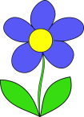  - Identify and describe the functions of different parts of flowering plants: roots, stem, leaves and flowers  - Explore the requirements of plants for life and growth (air, light, water, nutrients from soil, and room to grow).  - Investigate the way in which water is transported within plants  - Explore the part that flowers play in the life cycle of flowering plants, including pollination, seed formation and seed dispersal.

