Year 3 Creative Curriculum - Spring Term 2019
English  During this term we will be covering these text genres;  - Explanation Texts linked to our Science work on The Human Body.  - Narrative Poetry  - Fantasy Stories  We will be learning to;  - Create clear and imaginative plots for stories.  - Write compound sentences using the connectives and, or, but, so.  - Use ‘drop-in’ clauses to write complex sentences.  - Use fronted adverbials (where, when, how) to start sentences. E.g. A few days ago, we discovered a hidden box.  - Use commas in a list.  - Punctuate sentences using capital letters, full stops, exclamation marks, question marks. |  | Maths  We will be learning to;  - Measure, compare and order units of measure.  - Recognise fractions and their effect on shapes or numbers.  - Use written methods to multiply and divide.  - Tell and write the time with increasing accuracy.  - Recognise and identify angles.  - Interpret and present data using bar charts and tables.  Children will also be encouraged to learn their times-tables through weekly ‘hot seat’ testing.
Science – How Humans Work  Children will:  - Learn how we can make and hear sounds.  - Be able to identify different parts of human teeth and compare these to animal teeth.  - Find out how our body uses food and water.  - Learn about skeletons and muscles.  - Know which foods keep us healthy and why.  - Prepare a simple investigation which is fair with one changing factor.  - Learn how to predict the outcomes of investigations.  - Use simple scientific equipment  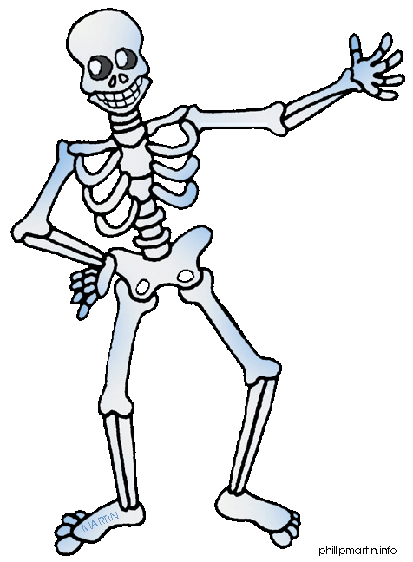  - Test ideas using evidence from observation and measurement.  - Use evidence to draw conclusions. | Music  We will be having weekly Violin, Viola or Recorder lessons taught by a specialist teacher from West Berkshire Maestros.  PE  Our focus will be on developing cognitive skills through working on balance and co-ordination.  RE  Hinduism and Easter  Computing  Working & Communicating Online  Social Emotional Aspects of Learning  Dreams & Goals  Healthy Me  Italian  Numbers, days of the week, months, seasons, rooms of the house, prepositions, shops, jobs and customs! |  | Science – Feel the Force  Science  Children will learn:  - What forces are and where they come from.  - What friction is and how we use friction.  - How we can reduce or increase friction.  - How to measure the strength of a force.  - How magnets and magnetic forces work.  - That different materials are suitable for different purposes  - How to carry out simple investigations.  Technology  Children will learn:  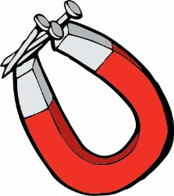  - How to design and make products to meet specific needs.  - How to make usable plans.  - How to use simple tools and equipment with some accuracy

