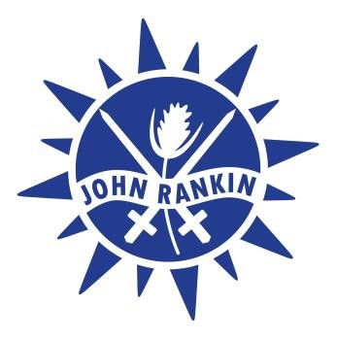
JOHN RANKIN SCHOOLS
‘Inspired to Learn – Challenged to Achieve’

Garford Crescent, Newbury, Berkshire, RG14 6EX
Telephone: 01635 42376
email: recruitment@jrs.w-berks.sch.uk
Executive Headteacher: Felix Rayner

Breakfast Club Playworker
3.75 hours per week, Monday-Friday, 7.55am-8.40am (Term time only)

Salary - Grade B, £17,364 - £18,065 FTE (£1,478 - £1,537 Actual)

John Rankin is a federation of a nursery, infant and junior school in Newbury. Our thriving three form entry schools are growing and we are looking for friendly and enthusiastic Breakfast Club Playworkers to come and join our team.

Are you:
- Capable of developing, planning and organising fun, engaging and stimulating play experiences?
- Committed to providing quality educational play experiences?
- Passionate about developing the whole child?
- Committed to being an active part of a team, able to form working relationships with excellent interpersonal skills?
- Highly motivated with experience of working within an educational play environment?

We can offer:
- Supportive, enthusiastic and motivated colleagues with great team spirit
- Forward thinking schools united in the drive to continue raising standards and achievement
- Amazing school grounds in a central location with great play potential
- Further opportunities for training and professional development
- Opportunities to have wider experience of working across our schools

Our school is a thriving and creative environment, where everyone matters – come and join us.
Have a look at our website http://www.jrs.w-berks.sch.uk for further information about our school. Visits to school are warmly welcomed and encouraged. Come and see for yourself what we have to offer. Application forms available from the school office and on our website.
Closing Date: Friday 18th October 2019
Interviews: w/c Monday 21st October 2019
John Rankin Federation is committed to safeguarding and promoting the welfare of children and young people and expects all staff to share this commitment. Successful candidates will be subject to enhanced DBS disclosure and checks with previous employers.

