Growth Mindset and Learning Behaviours
Parent Guide
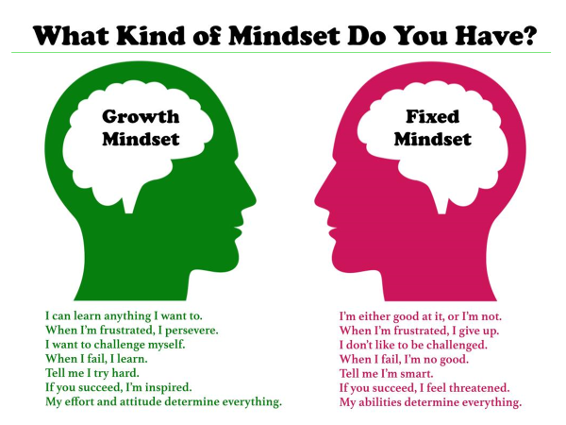
Holding a fixed or a growth mindset has huge implications when it comes to motivation. If children have a fixed notion of intelligence, they probably believe that success has a lot to do with talent. They may think that some are born with the ability to succeed, and others just aren’t. They might view successful people as possessing some unattainable, innate gift. The side effect of the fixed mindset is a helpless or apathetic attitude toward effort — especially when it comes to challenging tasks.
The simple belief that intelligence is malleable can better equip children for challenging tasks and difficult subject matter. If they know that they can develop their abilities, that effort and dedication make a difference in the formula for success, then children won’t become paralyzed by challenge.
The growth mindset creates a love of learning and a resilience that is essential for achieving goals.

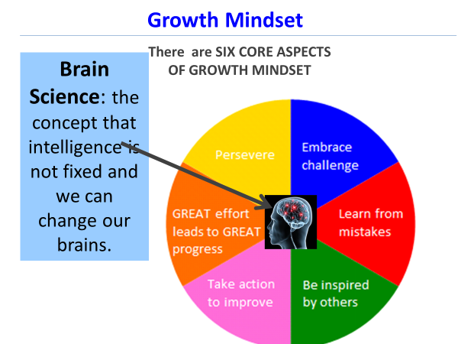

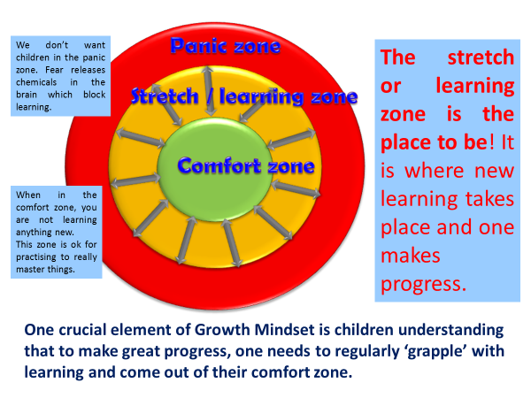

Say this......because........ | Not that..... because......
“I can see you worked so hard on this!”  It helps your children understand you value their efforts. | 'You are so smart!”  It makes them think of intelligence as a 'fixed quality'.
“It seems like it’s time to try a new strategy.”  It lets children know that they control outcomes by making choices. | “It’s okay. Maybe you’re just not cut out for this!”  It makes your children think they don't have the capacity to improve.
“I like watching you do that.”  It conveys the approval of an activity they enjoy doing, regardless of the outcome. | “You're a natural at that!”  The next time your children fail or make a mistake, they may think they don't have that ability after all.
“It looks like that was too easy for you. Let’s find you something challenging so your brain can grow.”  It teaches children that learning should be challenging and if tasks are too easy then your brain isn't growing. | “That’s right! You did that so quickly and easily; great job!”  Praising tasks completed without much effort paints effort in a negative light and encourages a fixed mindset.
“That’s not right. You don’t understand this yet. What strategies can you try to understand it better?”.  It's important to be honest about what your child knows and doesn't know but also explains that you believe in their capacity to improve. | “That’s not right. Are you paying attention in class? It seems like you’re not even trying.“  The fight or flight response may be preventing your child from giving their best response in class.
“That was really hard. Your effort has paid off! Next time you’ll be ready for this kind of challenge!”  Reminding children of how they were able to overcome challenges by putting lots of efforts cultivates a growth mindset | “That was really hard. I’m so glad it’s over and you don’t have to do that again.”  There will always be more challenges and children should feel that they have the tools for what comes next.
“You’ve worked hard to become a good writer. You should challenge yourself with an advanced class, and learn something you don’t know how to do yet.”  Putting your child in the challenge zone is how to inspire lifelong learning | “You have a real talent for writing. You should take a creative writing class because you’re so good at it.”  If you only encourage your child to do what they are good at, they will be afraid to take risks and learn new things.
Phrases that help children to develop a growth mindset

Developing Good Learning Behaviours in Children

At John Rankin Schools we believe that learning should be a life-long enterprise. We aim to develop our pupils’ Learning Behaviours, not just so they can complete school learning more easily and effectively, but so they will leave school with the ‘disposition’ (a set of habits and attitudes) which will serve them through the journey of life.
What are Learning Behaviours all about? Learning Behaviour or Power is about learning how to be a better learner. It is about the individual learner, their personal ‘disposition’ towards learning. They are a set of ‘learning muscles’ that need to be exercised so that they grow strong. This is something that can be learnt, practised and improved. It is a learning culture that encourages children and teachers to become better learners.
It allows children to;
- approach difficulties in learning without fear of failure
- take small steps within learning
- develop confidence in their abilities
- challenge themselves
- develop motivation and perseverance
It is not additional to teaching but should be grounded within everyday teaching and learning
It gives clear labels for the children to use to develop understanding of learning processes.

Promoting Learning Behaviours, in this way, allows us to develop a common language for learning across school. The language is used in all classrooms, with all children. This helps everyone talk about understanding learning to learn. We hope that this understanding will go beyond the school gates, where you will be able to reinforce the ideas by encouraging the children to use learning language in their everyday lives.
The idea is that the four dispositions (4 Rs) are like a group of ‘learning muscles’. Just as we can build our physical muscles with the right kind of exercise, learning muscles can also be developed and can grow in strength and stamina. It is these we are aiming to develop in the children.

There are four main learning dispositions:

Resilience: not giving up

Resourcefulness: being able to use a range of learning strategies and knowing what to do when you get stuck

Reflectiveness: being able to think about yourself as a learner and how you might be able to do this better

Reciprocity: being able to learn with and from others, as well as on your own

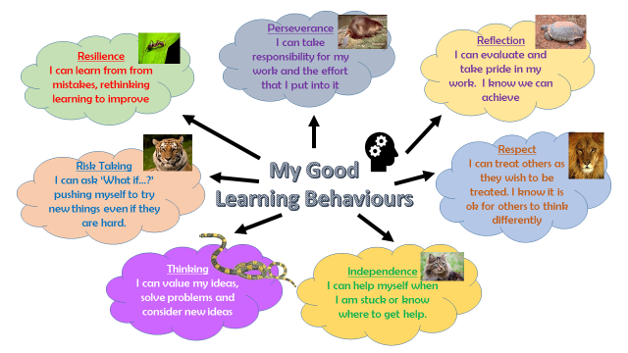
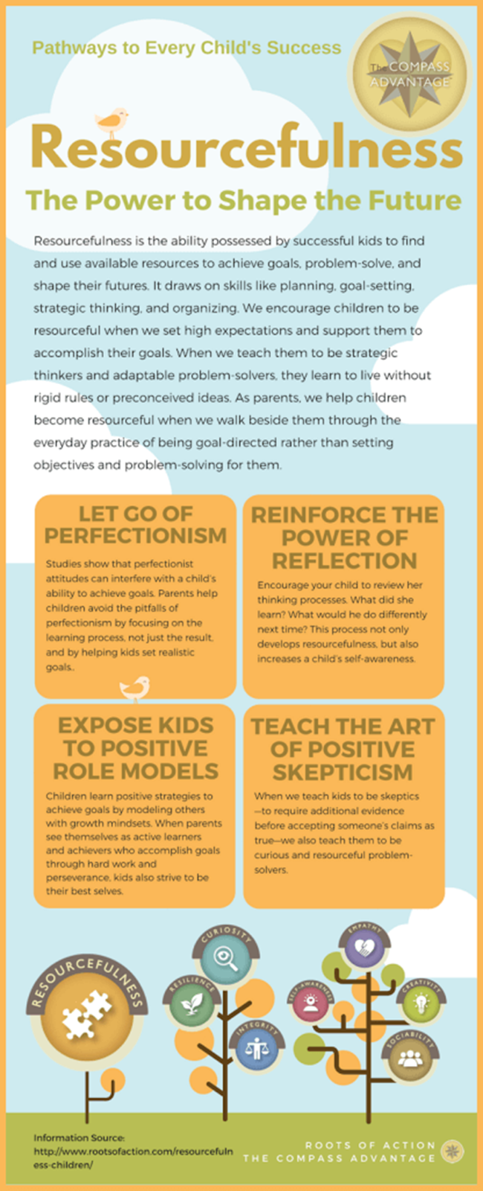
What is Independent Learning and how does it benefit children?

‘Independent Learning’ is often linked with other approaches to learning such as ‘personalisation’, ‘student-centred learning’ and ‘ownership’ of learning.
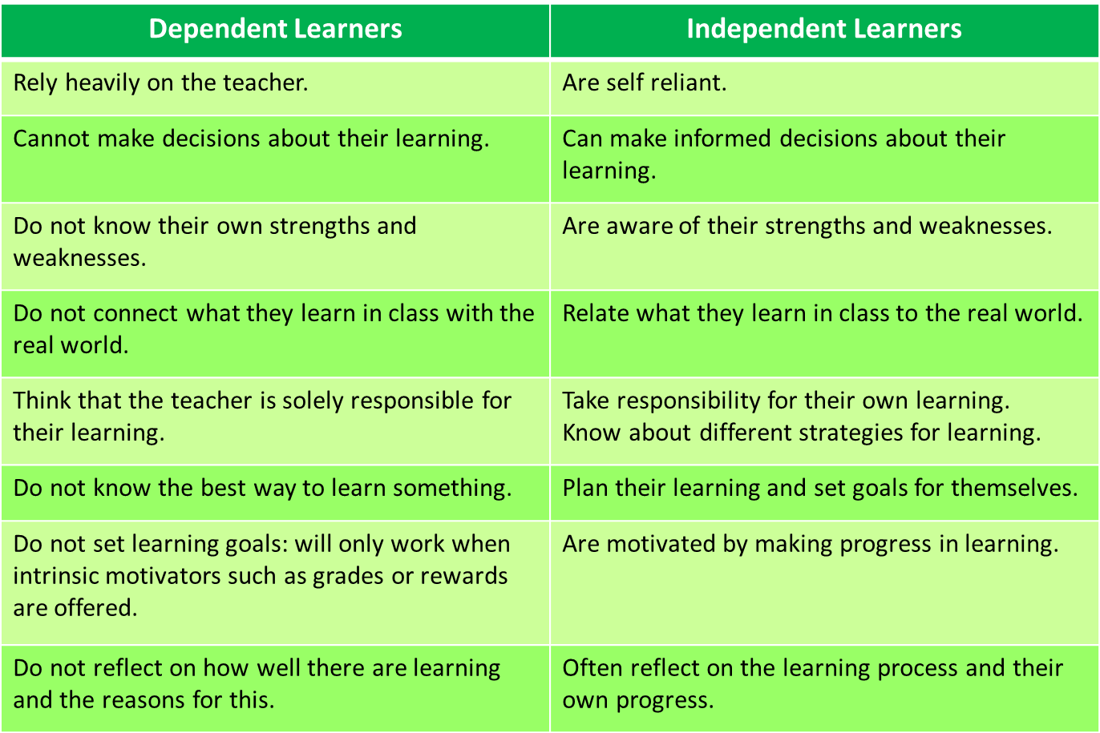

What are the benefits of independent learning for students?

How you can help at home?

- Ask your children about their learning muscles they have been using at school.

- Use the language of learning when undertaking tasks at home.
- If your child becomes stuck in their learning ask them to think of what they would have to do at school to get ‘unstuck’.
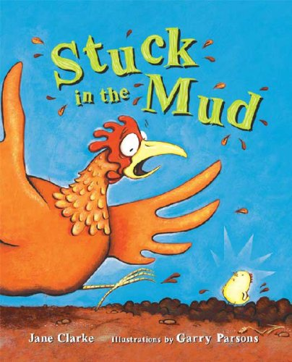

- Welcome and foster your child’s questioning spirit as much as you can.
- Involve them in your own learning activities. Try to “think aloud” as you try a new recipe or struggle with a bit of DIY. It helps children grow if they see that you too can struggle with uncertainty.
- Promote independence and Resourcefulness in everyday tasks – putting clothes on, making good choices, organising themselves.
- Let them make mistakes (and encourage them to find ways in which they can learn from them) – let them see you make mistakes (and stay calm, in order to find solutions)
- Encourage them to explain how they got to an answer or solution (reasoning)
First
Attempt
in

Learning

